Generate Token
My Account > Security > Generate Token
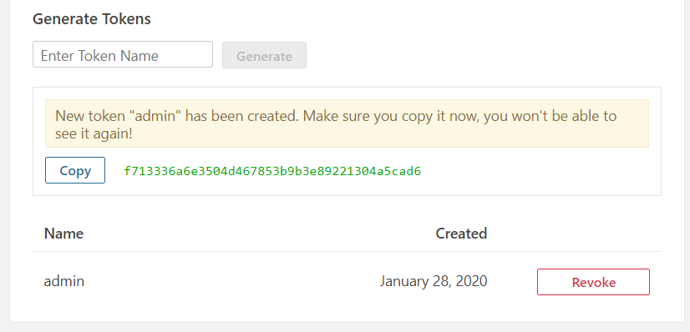

define the plugin in the pom.xml:
<build>
<pluginManagement>
<plugins>
<plugin>
<groupId>org.sonarsource.scanner.maven</groupId>
<artifactId>sonar-maven-plugin</artifactId>
<version>3.4.0.905</version>
</plugin>
</plugins>
</pluginManagement>
</build>

execute this command
mvn sonar:sonar -Dsonar.host.url=http://localhost:9000
-Dsonar.login=the-generated-token

# make sure – this command should be in Single line
mvn sonar:sonar -Dsonar.host.url=http://localhost:9000 -Dsonar.login=f713336a6e3504d467853b9b3e89221304a5cad6

Ref.
https://www.javatips.net/blog/sonarqube-tutorial

